Requirement Analysis Phase
Data Flow Diagram & User Stories
Date | 28 October 2026
Team ID | To Be Confirmed
Project Name | HotelPro – Hotel Management System
Maximum Marks | 4 Marks
Document Status | Draft v1.0 – prepared from the stated HotelPro requirements. No HotelPro source code has been provided or verified, so all features are marked Planned.

1. Data Flow Diagrams
A Data Flow Diagram (DFD) illustrates how data moves within HotelPro. It shows how users (guests, staff, managers and administrators) and external services interact with the system, how information flows between processes, and where data is stored. The diagrams follow Yourdon-style notation.
Table 1: DFD notation
Symbol | Meaning | Example
Rectangle (blue) | External entity – a person or system outside HotelPro | Guest, Payment Gateway
Circle (yellow) | Process – transforms data | 1.0 Authentication and Profile
Open rectangle (green) | Data store – MongoDB collection(s) | D3 Bookings
Arrow with label | Data flow | booking request

1.1 Level 0 – Context Diagram
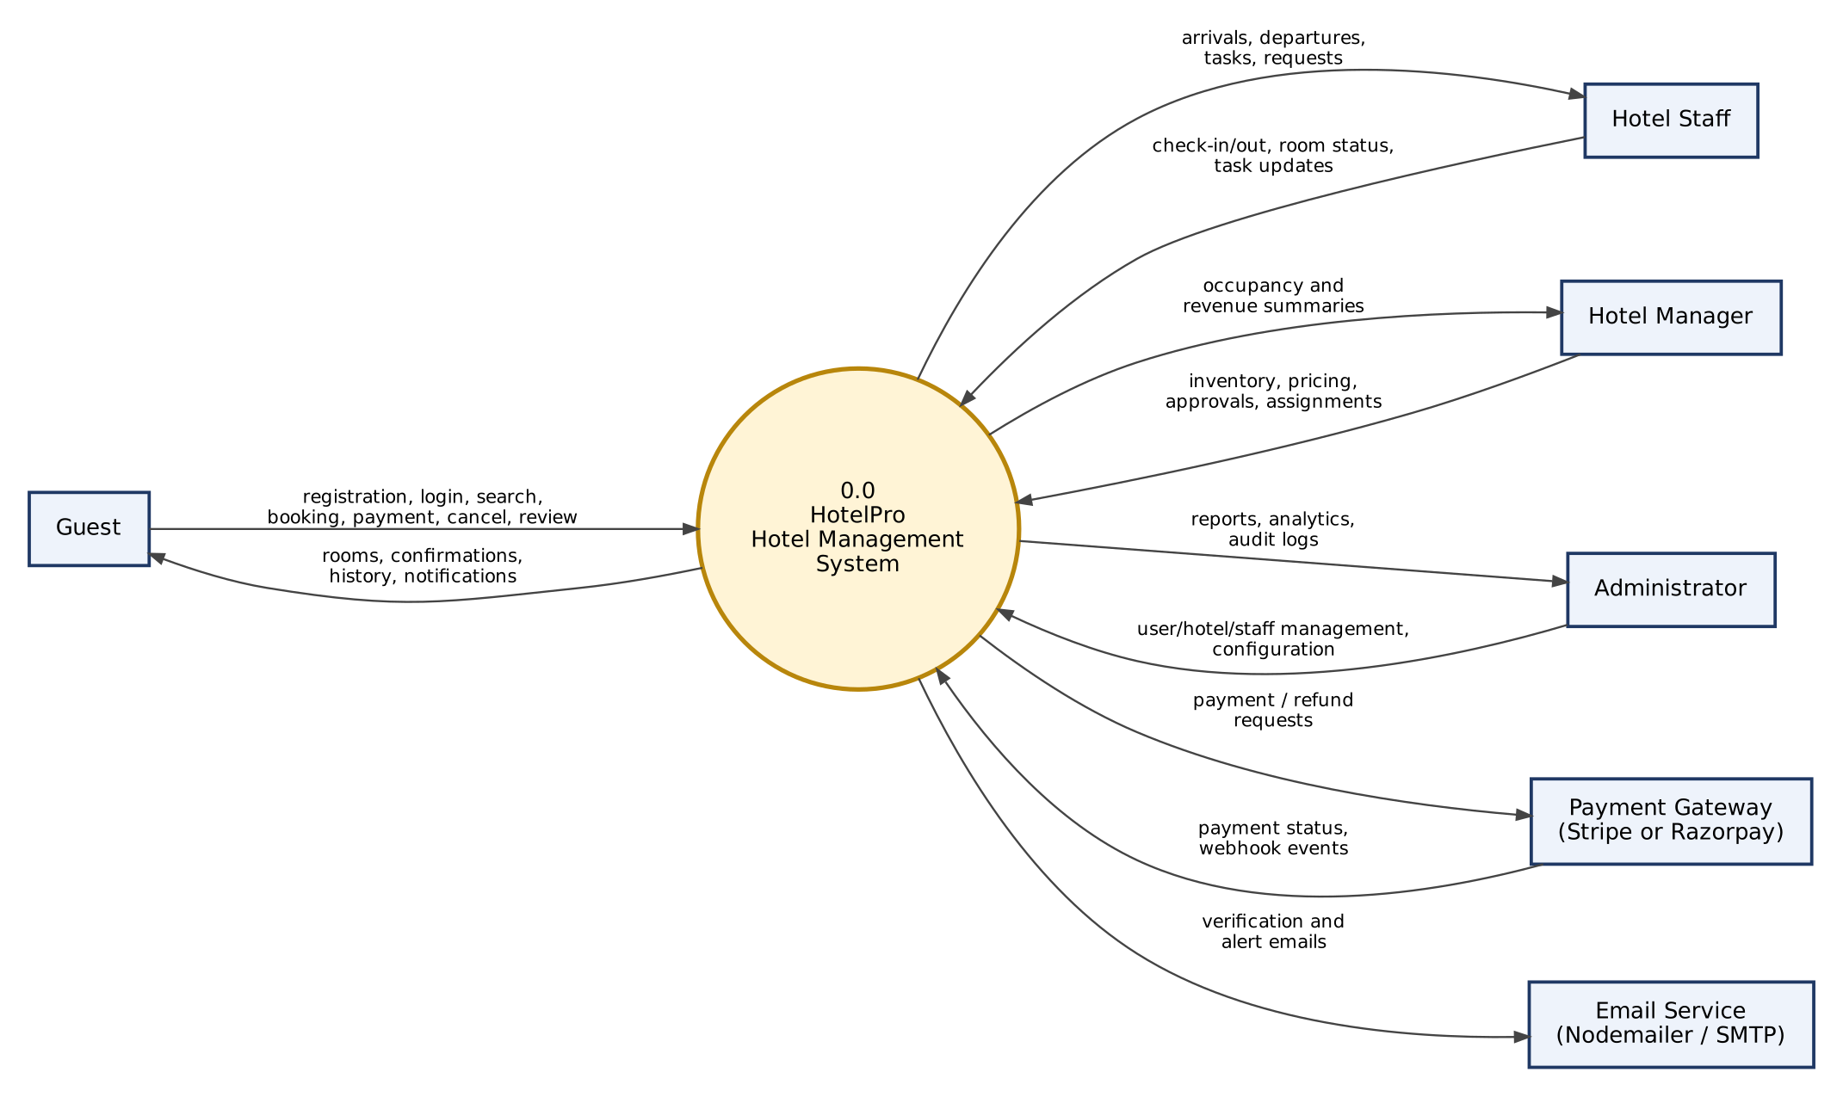
Figure 1: Level 0 DFD (context diagram) – HotelPro

1.2 Level 1 – Guest-Facing Processes
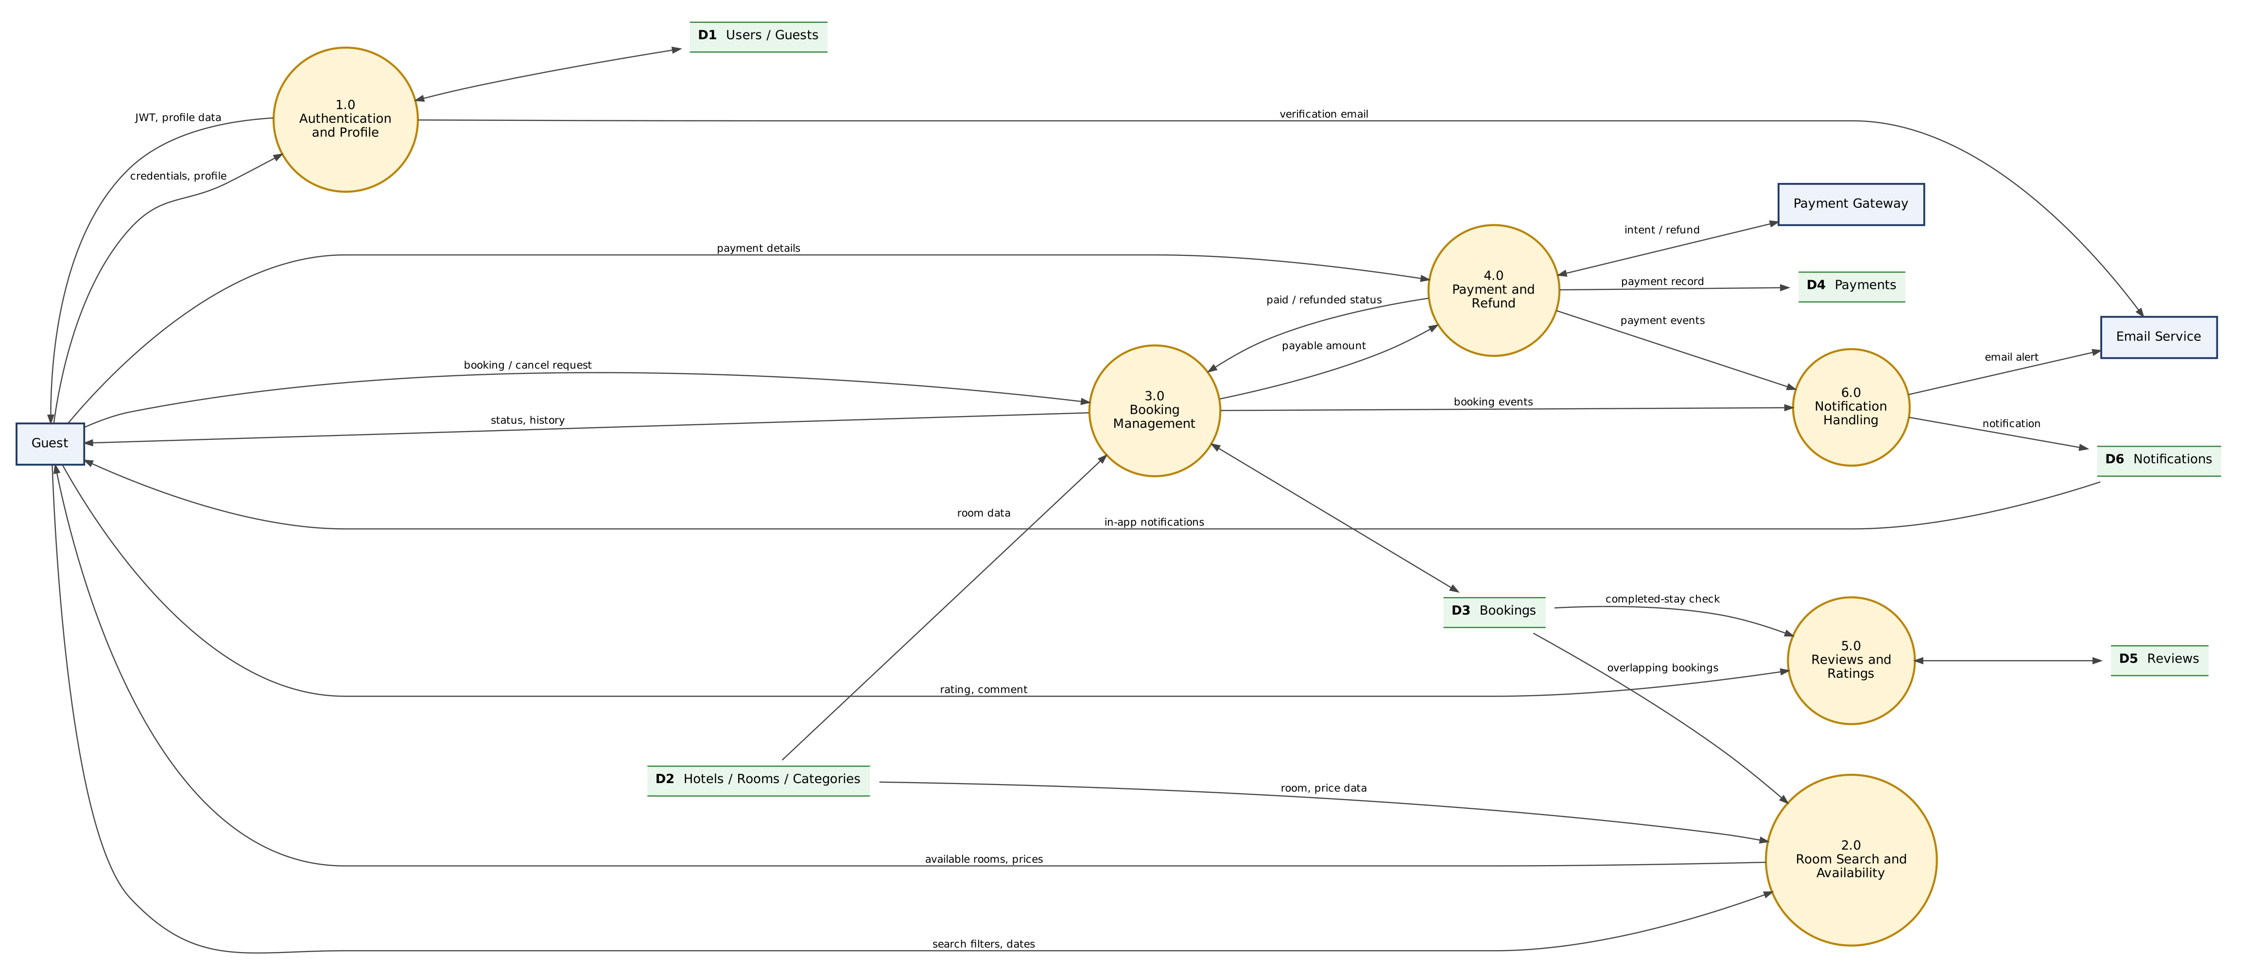
Figure 2: Level 1 DFD – authentication, search, booking, payment, reviews and notifications

1.3 Level 1 – Hotel Operations and Administration
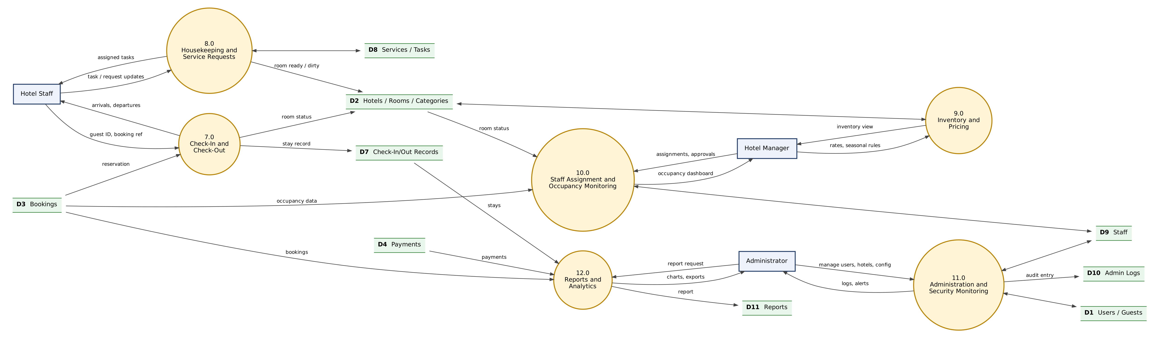
Figure 3: Level 1 DFD – check-in/out, housekeeping, pricing, occupancy, administration and reports

1.4 Level 2 – Booking and Payment (Processes 3.0 and 4.0)
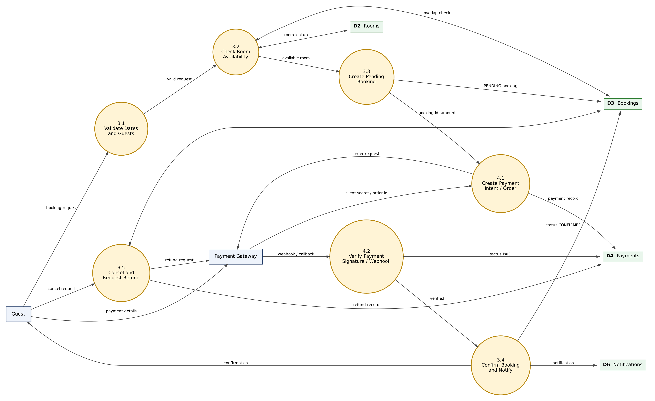
Figure 4: Level 2 DFD – booking creation, payment verification, confirmation and cancellation

1.5 Data Store and Process Dictionary
Table 2: Data store dictionary
Data Store | Collection(s) | Description
D1 | users, guests | Credentials, roles, profiles
D2 | hotels, rooms, roomCategories (and pricingRules) | Inventory, prices and room status
D3 | bookings | Reservations and their status
D4 | payments | Payment and refund records
D5 | reviews | Ratings and comments
D6 | notifications | In-app notification records
D7 | checkInOuts | Check-in and check-out records
D8 | services, serviceRequests, housekeepingTasks | Service catalogue, requests and tasks
D9 | staff | Staff profiles and assignments
D10 | adminLogs | Audit and security log
D11 | reports | Generated report snapshots

Table 3: Process dictionary
Process | Name | Main Inputs | Main Outputs
1.0 | Authentication and Profile | Credentials, profile data | JWT, profile, verification email
2.0 | Room Search and Availability | Dates, filters | Available rooms and prices
3.0 | Booking Management | Booking, cancel and modify requests | Booking status and history
4.0 | Payment and Refund | Payment details, gateway events | Payment records, paid/refunded status
5.0 | Reviews and Ratings | Rating and comment | Stored reviews
6.0 | Notification Handling | Booking and payment events | In-app and email notifications
7.0 | Check-In and Check-Out | Booking reference, guest ID | Stay record, room status
8.0 | Housekeeping and Service Requests | Task and request updates | Assigned tasks, room ready/dirty
9.0 | Inventory and Pricing | Rooms, rates, seasonal rules | Updated inventory
10.0 | Staff Assignment and Occupancy Monitoring | Assignments, approvals | Occupancy dashboard
11.0 | Administration and Security Monitoring | User/hotel/config changes | Audit log entries, alerts
12.0 | Reports and Analytics | Report request, source data | Charts, exports

2. User Stories
User stories follow the *As a [role], I can [action]* pattern. Acceptance criteria define when a story is complete. Priority and release (sprint) are proposed; story points and dependencies are detailed in the Project Planning Template.
User Story Table – HotelPro
User Type | Functional Requirement (Epic) | USN | User Story / Task | Acceptance Criteria | Priority | Release
Developer | Project Setup | USN-1 | As a developer, I can set up the repository, environment variables and MongoDB connection so the team works on a shared baseline. | App starts locally; .env.example documented; health route responds. | High | Sprint-1
Guest | Authentication | USN-2 | As a guest, I can register with name, email and password. | Account created with hashed password; duplicate email rejected with a clear message. | High | Sprint-1
User | Authentication | USN-3 | As a user, I can log in and receive a signed JWT so that I can access protected pages. | Valid credentials return a token and role; invalid credentials return 401. | High | Sprint-1
Guest | Authentication | USN-4 | As a guest, I can verify my email address through a link sent to me. | Unverified accounts are flagged; verified status is stored after the link is opened. | Medium | Sprint-1
User | Role-Based Security | USN-5 | As a user, I can only open pages and APIs allowed for my role. | Guest, Staff and Admin routes return 403 for unauthorised roles. | High | Sprint-1
User | Authentication | USN-6 | As a user, I can reset a forgotten password. | Time-limited reset link works once; old password stops working. | Medium | Sprint-1
Hotel Manager | Room Inventory | USN-7 | As a hotel manager, I can add and edit rooms and room categories with base prices. | Room appears in inventory; validation blocks missing price or capacity. | High | Sprint-2
Hotel Manager | Room Inventory | USN-8 | As a hotel manager, I can upload room images. | Only allowed image types and sizes are accepted; image shows on room page. | Medium | Sprint-2
Guest | Room Browsing | USN-9 | As a guest, I can browse the list of rooms with pagination. | Rooms load in pages; empty state shown when none found. | High | Sprint-2
Guest | Room Search | USN-10 | As a guest, I can search and filter rooms by dates, guests, type and price. | Results match every filter; unavailable rooms are excluded for chosen dates. | High | Sprint-2
Guest | Room Browsing | USN-11 | As a guest, I can view room details, amenities and reviews. | Details page shows images, amenities, price and rating. | High | Sprint-2
Admin | Hotel Management | USN-12 | As a admin, I can create and manage hotel records. | Hotel saved and visible in admin list; edits are logged. | Medium | Sprint-2
Guest | Booking | USN-13 | As a guest, I can book an available room for chosen dates. | Pending booking is created with correct total and a booking reference. | High | Sprint-3
Guest | Booking | USN-14 | As a guest, I am prevented from booking a room that is already reserved for overlapping dates. | Overlapping request is rejected, including under concurrent requests. | High | Sprint-3
Guest | Booking History | USN-15 | As a guest, I can view my booking history and status. | List shows all my bookings with status, dates and total. | High | Sprint-3
Hotel Manager | Booking Modification | USN-16 | As a hotel manager, I can approve or reject a guest's change request for dates or room. | Approved change re-validates availability and updates the price. | Medium | Sprint-3
Guest | Cancellation | USN-17 | As a guest, I can cancel a booking according to the cancellation policy. | Status becomes CANCELLED; room is released; refund eligibility is calculated. | High | Sprint-3
Guest | Online Payment | USN-18 | As a guest, I can pay for a booking online. | Payment intent/order is created; success moves booking to CONFIRMED. | High | Sprint-4
Guest | Online Payment | USN-19 | As a guest, My payment is verified server-side before confirmation. | Tampered or unsigned callbacks are rejected; amount is checked. | High | Sprint-4
Guest | Refunds | USN-20 | As a guest, I can request a refund for an eligible cancellation. | Refund request is tracked until approved or rejected. | Medium | Sprint-4
Guest | Notifications | USN-21 | As a guest, I receive email confirmations for key booking events. | Email is sent on confirmation and cancellation; failures are logged. | Medium | Sprint-4
User | Notifications | USN-22 | As a user, I can see in-app notifications and mark them as read. | Unread count updates; list is paginated. | Medium | Sprint-4
Staff | Check-In / Check-Out | USN-23 | As a staff, I can check a guest in against a confirmed booking. | Check-in record saved; room status becomes OCCUPIED. | High | Sprint-5
Staff | Check-In / Check-Out | USN-24 | As a staff, I can check a guest out and settle the final bill. | Check-out record saved; room becomes DIRTY; booking COMPLETED. | High | Sprint-5
Staff | Room Status | USN-25 | As a staff, I can update the status of a room. | Status changes are saved with time and user. | High | Sprint-5
Staff | Housekeeping | USN-26 | As a staff, I can view and complete housekeeping tasks. | Completing a task marks the room AVAILABLE. | Medium | Sprint-5
Guest | Service Requests | USN-27 | As a guest, I can request a hotel service during my stay. | Request is visible to staff and tracked to completion. | Medium | Sprint-5
Hotel Manager | Seasonal Pricing | USN-28 | As a hotel manager, I can define seasonal pricing rules. | Price for dates inside a season uses the seasonal rate. | Medium | Sprint-5
Hotel Manager | Staff Assignment | USN-29 | As a hotel manager, I can assign staff to tasks and shifts. | Assigned staff see the task on their dashboard. | Medium | Sprint-5
Hotel Manager | Occupancy Monitoring | USN-30 | As a hotel manager, I can monitor current and forecast occupancy. | Dashboard shows occupied, available and out-of-service counts. | Medium | Sprint-5
Guest | Reviews | USN-31 | As a guest, I can rate and review a completed stay. | Only guests with completed bookings can review; one review per booking. | Medium | Sprint-6
Guest | Customer Support | USN-32 | As a guest, I can raise a support request and receive a reply. | Ticket is created and visible to staff. | Low | Sprint-6
Admin | Administration | USN-33 | As a admin, I can manage users and staff accounts. | Admin can activate, deactivate and change roles; actions are logged. | High | Sprint-6
Admin | Payment Tracking | USN-34 | As a admin, I can track all payments and refunds. | Filterable payment list with status and totals. | Medium | Sprint-6
Admin | Reports and Analytics | USN-35 | As a admin, I can view booking, occupancy and revenue reports with charts. | Charts match underlying data for a selected date range. | Medium | Sprint-6
Admin | Security Monitoring | USN-36 | As a admin, I can review activity and security logs. | Login failures and admin actions appear in the log view. | Medium | Sprint-6
Admin | Platform Configuration | USN-37 | As a admin, I can configure platform settings such as cancellation policy and tax rate. | Changes apply to new bookings only. | Low | Sprint-6
Developer | Security Hardening | USN-38 | As a developer, I can ensure all inputs are validated and sanitised. | Invalid and malicious payloads are rejected on every write endpoint. | High | Sprint-7
Guest | Responsive Design | USN-39 | As a guest, I can use the application comfortably on mobile and tablet. | Key pages render without horizontal scroll at 360 px width. | Medium | Sprint-7
Tester | Testing | USN-40 | As a tester, I can execute the planned test cases and log defects. | All Priority-High test cases executed; defects tracked to closure. | High | Sprint-7
Developer | Performance | USN-41 | As a developer, I can add database indexes and pagination to heavy queries. | Search and listing queries use indexes (verified with explain). | Medium | Sprint-7
Developer | Deployment | USN-42 | As a developer, I can deploy the application to a hosted environment. | Frontend and API reachable over HTTPS; environment variables configured. | Medium | Sprint-7

References
- Data Flow Diagrams – Visual Paradigm Guide – https://www.visual-paradigm.com/tutorials/data-flow-diagram-dfd.jsp
- User Stories – Atlassian Agile Coach – https://www.atlassian.com/agile/project-management/user-stories

